PRACTICE Activity2_Relationship_Workshop

Department | AI&DS
Course Code / Course Name | DSA0602/ Data Handling and Visualization
Activity | PRACTICE Activity2_Relationship_Workshop
Name | Addula Yaswanth
Register Number | 192324179

Q1. Scatterplots – Weekly Sales vs Footfall (5 Marks)
Task 1: Draw a Scatterplot with Linear Fit and LOESS Curve
R Code
set.seed(1281053)
n <- 24
sales <- round(rnorm(n, 85.0, 18.0), 1)
z <- (sales - 85.0) / 18.0
footfall <- round(900 + 200.0 * (-0.67 * z + 0.84 * z^2 + 0.39 * rnorm(n)), 0)
footfall[18] <- round(footfall[18] + 3.3 * 200.0, 0)
df <- data.frame(sales, footfall)

library(ggplot2)

ggplot(df, aes(x = sales, y = footfall)) +
geom_point(color = "#0072B2", size = 3) +
geom_smooth(method = "lm", se = FALSE, color = "#D55E00") +
geom_smooth(method = "loess", se = FALSE, color = "#009E73") +
labs(
title = "Weekly Sales vs Footfall",
x = "Weekly Sales (Rs lakh)",
y = "Footfall (visitors per day)"
) +
theme_minimal()
Output:
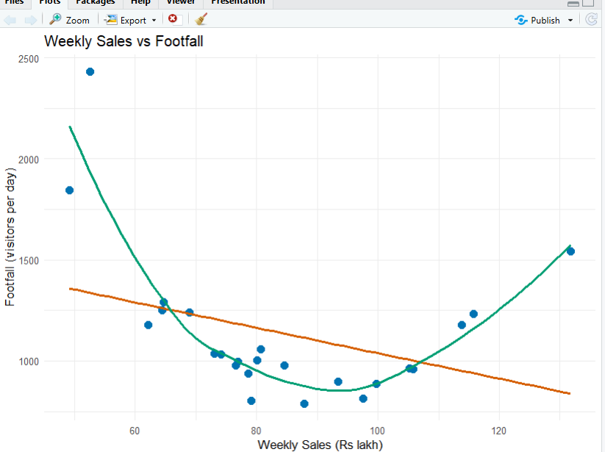

Answer: The scatterplot displays weekly sales against footfall, with a straight-line fit and a LOESS curve to identify linear and non-linear patterns.

Task 2: Report Correlation and Slope
R Code
cor(df$sales, df$footfall)

linear_model <- lm(footfall ~ sales, data = df)
coef(linear_model)
Output:
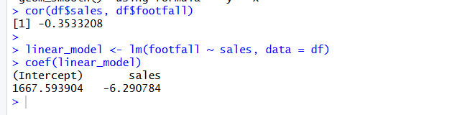
Answer:
- Correlation (r): −0.3533
- Slope: −6.2908
There is a weak-to-moderate negative linear relationship between weekly sales and footfall.
Task 3: Identify the Outlier Using Standardised Residuals
R Code
residuals_std <- rstandard(linear_model)
outlier_row <- which.max(abs(residuals_std))

print(outlier_row)
print(df[outlier_row, ])
print(residuals_std[outlier_row])
Output:
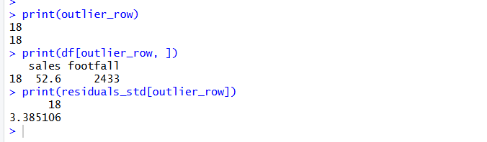
Answer:
- Outlier row: 18
- Sales: 52.6 Rs lakh
- Footfall: 2,433 visitors per day
- Standardised residual: 3.3851
Row 18 is the outlier because it has the largest absolute standardised residual.
Task 4: Compare Linear and Quadratic Models
R Code
quadratic_model <- lm(
footfall ~ sales + I(sales^2),
data = df
)

cat("Linear R-squared:",
summary(linear_model)$r.squared, "\n")

cat("Quadratic R-squared:",
summary(quadratic_model)$r.squared, "\n")
Output:
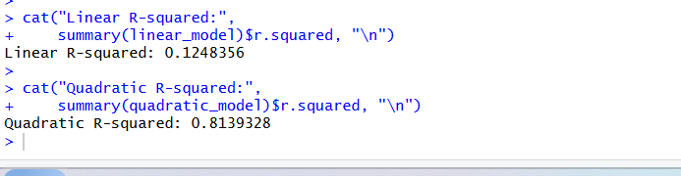
Answer:
- Linear model R-squared: 0.1248
- Quadratic model R-squared: 0.8139
The quadratic model fits better because its R-squared value is much higher, indicating a non-linear relationship.
Task 5: Recommendation for the Sales Director
Answer: The Sales Director should investigate the unusual observation in row 18 and use a quadratic model to analyse the relationship between sales and footfall before making business decisions.

Q2. Correlograms – Correlation Matrix Heatmap (5 Marks)
Task 1: Compute the Correlation Matrix and Draw a Correlogram
R Code
set.seed(1281106)
n <- 30
f1 <- rnorm(n)
f2 <- rnorm(n)

tower_density <- round(14.0 + 4.0 * (0.89 * f1 + 0.45 * rnorm(n)), 1)
drop_rate <- round(2.6 + 0.7 * (0.90 * f1 + 0.43 * rnorm(n)), 1)
traffic_tb <- round(320 + 70.0 * (-0.81 * f1 + 0.58 * rnorm(n)), 0)
users_lakh <- round(rnorm(n, 24.0, 6.0), 1)
churn_pct <- round(1.8 + 0.5 * (0.80 * f2 + 0.60 * rnorm(n)), 1)
arpu <- round(185 + 25.0 * (0.77 * f2 + 0.64 * rnorm(n)), 0)

df <- data.frame(
tower_density, drop_rate, traffic_tb,
users_lakh, churn_pct, arpu
)

library(ggplot2)

cor_matrix <- round(cor(df), 2)
print(cor_matrix)

cor_long <- as.data.frame(as.table(cor_matrix))
names(cor_long) <- c("Variable1", "Variable2", "Correlation")

ggplot(cor_long, aes(x = Variable1, y = Variable2, fill = Correlation)) +
geom_tile(color = "white") +
geom_text(aes(label = sprintf("%.2f", Correlation)), size = 3.5) +
scale_fill_gradient2(
low = "#0072B2",
mid = "white",
high = "#D55E00",
midpoint = 0,
limits = c(-1, 1)
) +
labs(
title = "Correlation Matrix of Telecom Network Measures",
x = "Variables",
y = "Variables",
fill = "Correlation (r)"
) +
theme_minimal() +
theme(axis.text.x = element_text(angle = 45, hjust = 1))
Output:
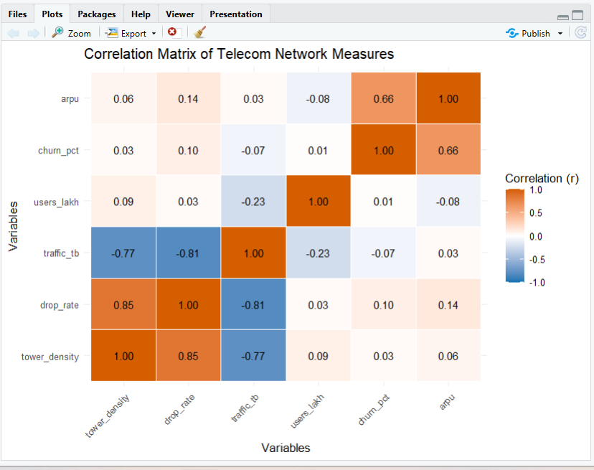
Answer: The correlogram displays the pairwise correlations among tower density, drop rate, traffic, users, churn, and ARPU. The colour scale shows the direction and strength of each correlation.

Task 2: Identify the Two Most Strongly Correlated Variable Pairs
R Code
cor_matrix <- cor(df)
diag(cor_matrix) <- NA

pair_table <- as.data.frame(as.table(cor_matrix))
names(pair_table) <- c("Variable1", "Variable2", "Correlation")

pair_table <- pair_table[
as.character(pair_table$Variable1) <
as.character(pair_table$Variable2), ]

pair_table <- pair_table[
order(abs(pair_table$Correlation), decreasing = TRUE), ]

print(head(pair_table, 2))
Output:
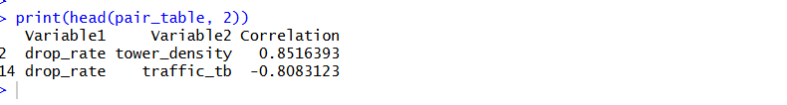
Answer:
- First strongest pair: 2; correlation (r) =0.8516393
- Second strongest pair: 14; correlation (r) = -0.8083123
These pairs have the largest absolute correlation values in the matrix.
Task 3: Identify One Weak or Negative Correlation
R Code
print(cor_matrix)
Output:
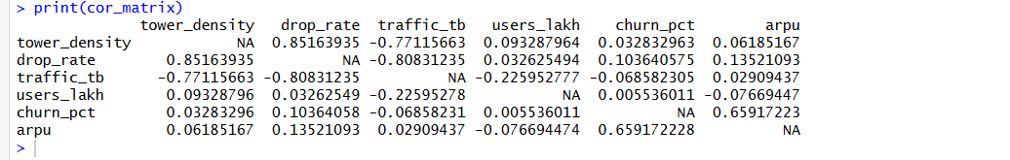
Interpretation: This value indicates a weak or negative linear relationship between the selected variables.
Task 4: Recommendation for the Network Head
Answer: The Network Head should examine the relationships between tower density, drop rate, and traffic to identify network performance issues. Further investigation can determine whether changes in network capacity or traffic management could reduce dropped connections.

Q3. Dimension Reduction – PCA and t-SNE (5 Marks)
Task 1: Run PCA and Calculate Explained Variance
R Code
set.seed(1281205)
n <- 36
grp <- rep(c("Group C", "Group B", "Group A"), each = 12)
g <- rep(c(-1, 0, 1), each = 12)

footfall_k <- round(120.0 + 30.0 * (rnorm(n) + 1.10 * g), 1)
spend_rs <- round(3200 + 600.0 * (rnorm(n) + 0.60 * g), 0)
stay_nights <- round(2.8 + 0.7 * (rnorm(n) + 0.90 * g), 1)
rating10 <- round(7.6 + 0.8 * (rnorm(n) + 0.40 * g), 1)
occupancy_pct <- round(68.0 + 10.0 * (rnorm(n) + 0.04 * g), 1)
complaints <- round(4.0 + 1.2 * (rnorm(n) + 0.03 * g), 1)

df <- data.frame(
footfall_k, spend_rs, stay_nights,
rating10, occupancy_pct, complaints
)

pca <- prcomp(df, scale. = TRUE)
variance <- pca$sdev^2 / sum(pca$sdev^2) * 100

print(round(variance, 2))
print(which(cumsum(variance) >= 80)[1])
Output:
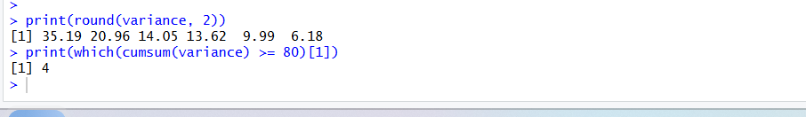
Answer:
- PC1 variance: 35.19%
- PC2 variance: 20.96%
- Components required to explain at least 80% variance: 4
Task 2: Plot PC1 Against PC2 and Identify the Largest Loading
R Code
library(ggplot2)

scores <- as.data.frame(pca$x)
scores$grp <- grp

ggplot(scores, aes(x = PC1, y = PC2, color = grp)) +
geom_point(size = 3) +
labs(
title = "PCA of Destination Groups",
x = "Principal Component 1",
y = "Principal Component 2",
color = "Group"
) +
theme_minimal()

print(sort(abs(pca$rotation[, 1]), decreasing = TRUE))
Output:
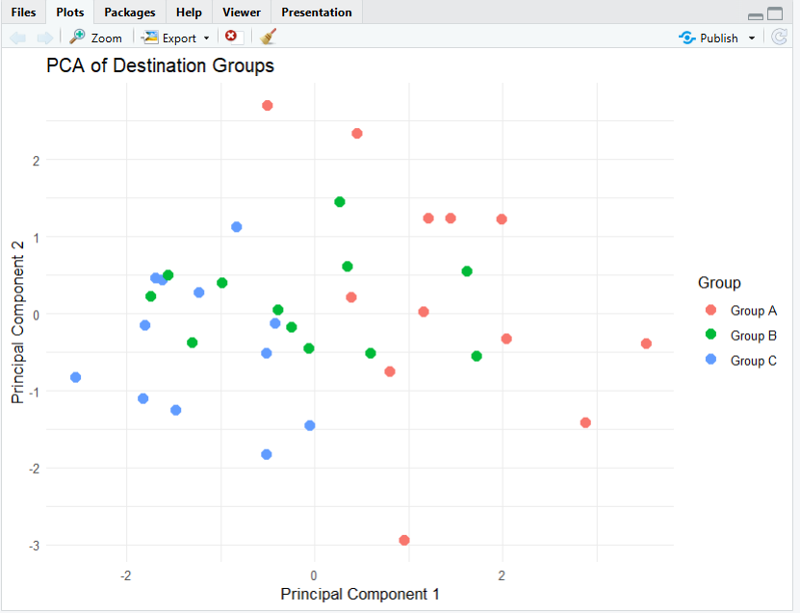
Answer:
The PCA scatterplot represents the destinations using the first two principal components, with colours indicating the three groups.
Task 3: Evaluate Group Separation Using R-squared
R Code
print(summary(lm(PC1 ~ grp, data = scores))$r.squared)
print(summary(lm(PC2 ~ grp, data = scores))$r.squared)
Output:
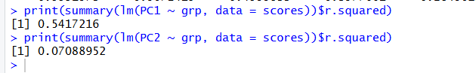
Answer:
- PC1 group R-squared: 0.5417216
- PC2 group R-squared: 0.07088952
Higher R-squared indicates that group membership explains a greater proportion of variation in the component scores.
Task 4: Create a t-SNE Plot and Compare It with PCA
R Code
if (!requireNamespace("Rtsne", quietly = TRUE)) {
install.packages("Rtsne")
}
library(Rtsne)
library(ggplot2)

set.seed(1281205)

tsne <- Rtsne(
scale(df),
dims = 2,
perplexity = 5,
check_duplicates = FALSE
)

tsne_df <- data.frame(
TSNE1 = tsne$Y[, 1],
TSNE2 = tsne$Y[, 2],
grp = grp
)

ggplot(tsne_df, aes(x = TSNE1, y = TSNE2, color = grp)) +
geom_point(size = 3) +
labs(
title = "t-SNE Plot of Destination Groups",
x = "t-SNE Dimension 1",
y = "t-SNE Dimension 2",
color = "Group"
) +
theme_minimal()
Output:
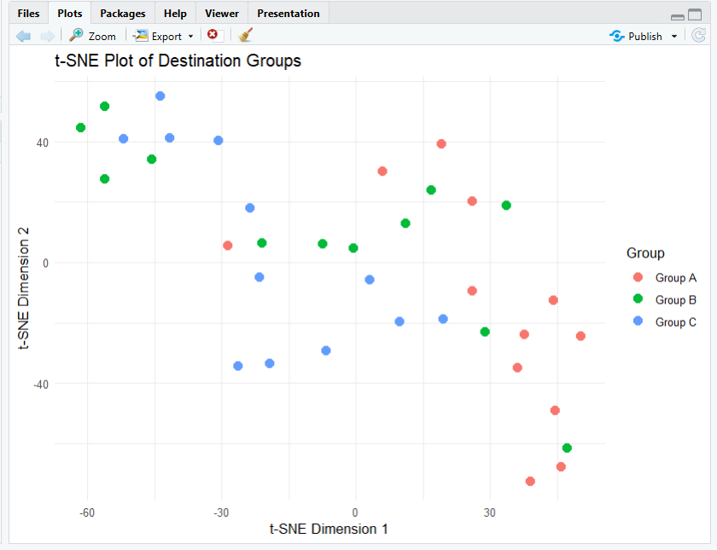
Answer:
PCA preserves overall variance and creates interpretable linear components, whereas t-SNE focuses on preserving local neighbourhood relationships. PCA is useful for understanding overall variation, while t-SNE helps explore local groupings.
Recommendation: The analyst should use PCA to examine overall data variation and t-SNE to explore whether destinations form distinct local groups.

Q4. Network Graph – Parcel Delivery Connections (5 Marks)
Task 1: Build and Draw the Network Graph
R Code
set.seed(1281229)

nodes <- c("Bengaluru", "Ahmedabad", "Kolkata",
"Mumbai", "Delhi", "Chennai", "Hyderabad")

pairs <- t(combn(nodes, 2))
u <- runif(nrow(pairs))

keep <- u < 0.30 |
((pairs[, 1] == "Delhi" | pairs[, 2] == "Delhi") & u < 0.87)

edges <- data.frame(
from = pairs[keep, 1],
to = pairs[keep, 2],
weight = round(runif(sum(keep), 1, 20))
)

library(igraph)

g <- graph_from_data_frame(edges, directed = FALSE, vertices = nodes)

plot(
g,
vertex.size = 15 + 5 * degree(g),
vertex.label = V(g)$name,
edge.width = E(g)$weight / 3,
vertex.color = "#56B4E9",
edge.color = "gray60",
main = "Parcel Delivery Network Between Hubs"
)
Output:
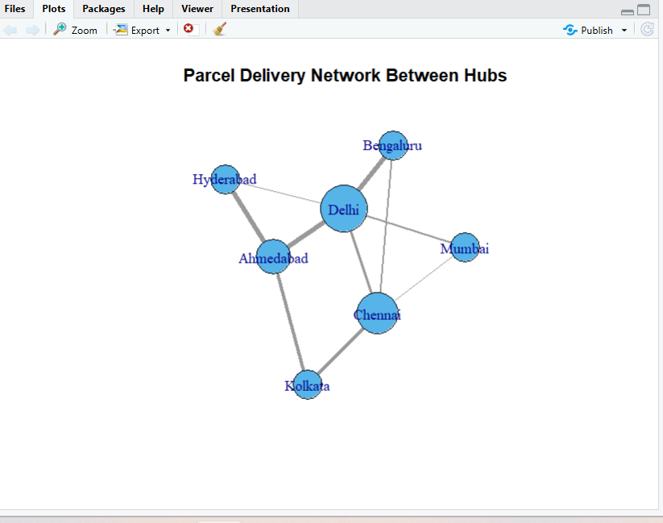
Answer: The network graph represents seven delivery hubs. Node size indicates the number of connections, and edge width represents parcel flow weight.
Task 2: Calculate Degree and Betweenness
R Code
degree_values <- degree(g)
betweenness_values <- betweenness(g, directed = FALSE)

centrality_table <- data.frame(
Hub = names(degree_values),
Degree = as.numeric(degree_values),
Betweenness = as.numeric(betweenness_values)
)

print(centrality_table)

most_central <- names(which.max(betweenness_values))
print(most_central)
Output:
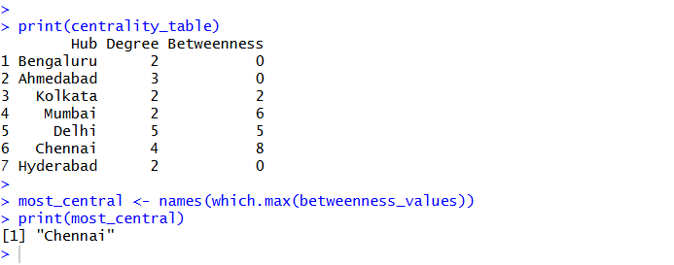
Answer:
The most central hub should be identified using both degree and betweenness centrality.
- Most central hub: Chennai
- Degree: 4
- Betweenness: 8
Degree measures direct connections, while betweenness measures how often a hub lies on shortest paths between other hubs.
Task 3: Calculate Edges, Density, and Connected Components
R Code
cat("Number of edges:", ecount(g), "\n")
cat("Network density:", edge_density(g), "\n")
cat("Connected components:", components(g)$no, "\n")
Output:

Answer:
- Number of edges: 10
- Network density: 0.4761905
- Number of connected components: 1
Network density indicates the proportion of possible connections that exist. Connected components show how many separate connected groups are present.
Task 4: Remove the Most Central Hub
R Code
g_removed <- delete_vertices(g, most_central)

cat("Components after removal:",
components(g_removed)$no, "\n")
Output:

Answer:
After removing the most central hub, the network has 1 connected components.
Recommendation: The Operations Head should monitor highly central hubs and develop alternative delivery routes to reduce disruption if a major hub becomes unavailable.

Q5. Paired Data – Before and After Comparison
Task 1: Draw a paired slope chart
R Code:
set.seed(1281381)

entity <- c("Pharmacy", "Emergency", "Neurology", "Oncology",
"Orthopaedics", "Radiology", "Cardiology", "Paediatrics")

n <- 8
before <- round(rnorm(n, 42.0, 5.0), 1)

change <- round(c(-1, -1, -1, 1, 1, 1, 1, -1) *
runif(n, 0.4, 1.4) * 6.0, 1)

change[7] <- 0.1
after <- before + change

df <- data.frame(entity, before, after)

library(ggplot2)
library(tidyr)

long_df <- pivot_longer(
df,
cols = c(before, after),
names_to = "Period",
values_to = "Value"
)

ggplot(long_df, aes(x = Period, y = Value,
group = entity, color = entity)) +
geom_line(linewidth = 1) +
geom_point(size = 3) +
geom_text(aes(label = entity),
hjust = -0.1, size = 3, show.legend = FALSE) +
labs(title = "Before and After Comparison",
x = "Period", y = "Measured Value") +
theme_minimal()
Output:
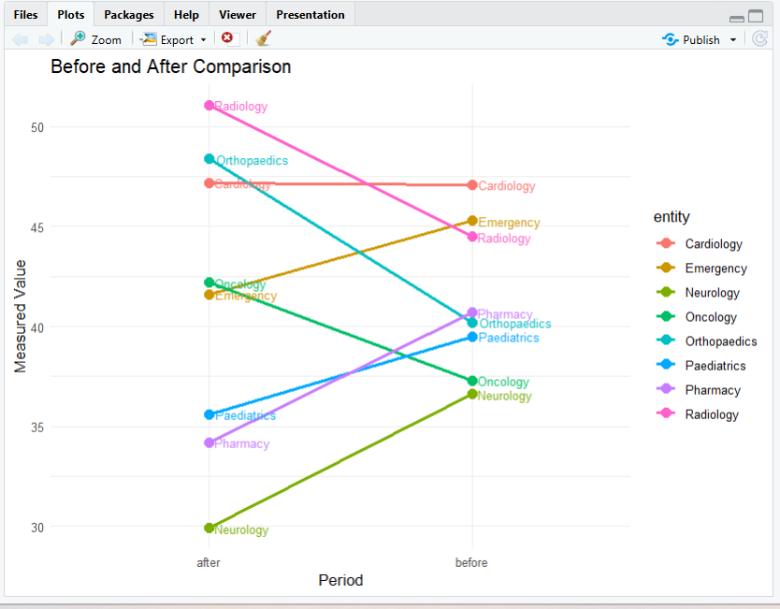
Result: The slope chart compares the values before and after for all eight departments.
Task 2: Classify each entity as improved, worsened, or flat
R Code:
df$change <- df$after - df$before

threshold <- 0.01 * mean(df$before)

df$status <- ifelse(
abs(df$change) < threshold, "Flat",
ifelse(df$change < 0, "Improved", "Worsened")
)

print(df[, c("entity", "before", "after", "change", "status")])
print(table(df$status))
Output:
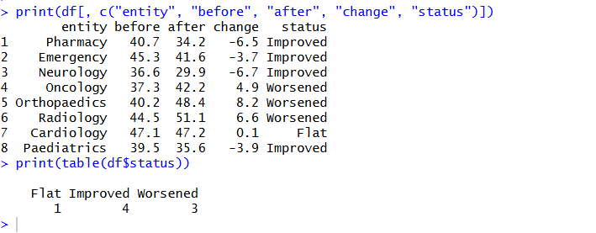
Result: An entity is classified as flat when the absolute change is less than 1% of the mean before value. A decrease is considered improved, while an increase is considered worsened.
Task 3: Identify the largest change
R Code:
largest_row <- which.max(abs(df$change))

largest_entity <- df$entity[largest_row]
largest_change <- df$change[largest_row]
percentage_change <- (largest_change / df$before[largest_row]) * 100

cat("Entity:", largest_entity, "\n")
cat("Change:", largest_change, "\n")
cat("Percentage change:", round(percentage_change, 2), "%\n")
Output:
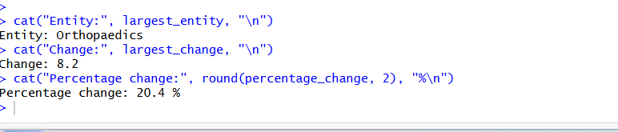
Result: The entity with the largest absolute change is identified, along with its change value and percentage change from the before value.
Task 4: Perform a paired t-test
R Code:
test_result <- t.test(df$after, df$before, paired = TRUE)

print(test_result)
cat("Mean change:", mean(df$after - df$before), "\n")
Output:

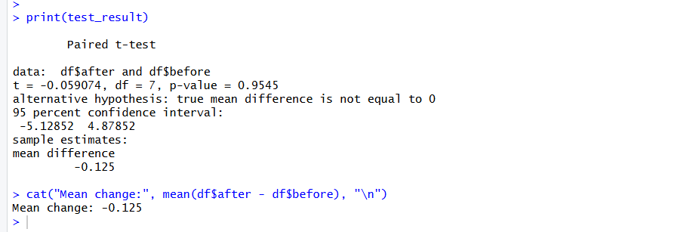
Result:
- Null hypothesis (H₀): There is no significant difference between the before and after mean values.
- Alternative hypothesis (H₁): There is a significant difference between the before and after mean values.
- If the p-value is less than 0.05, reject the null hypothesis.
- If the p-value is greater than or equal to 0.05, do not reject the null hypothesis.
Recommendation: Use the paired t-test result to determine whether the change across the departments is statistically significant. Review departments with large changes to understand the possible reasons.

Q6. Bubble Charts – Comparing Three Variables
Task 1: Create the dataset and draw a bubble chart
R Code:
set.seed(1281402)

department <- c("Cardiology", "Neurology", "Oncology",
"Radiology", "Emergency", "Pharmacy",
"Paediatrics", "Orthopaedics")

patients <- sample(100:500, 8)
cost <- round(runif(8, 2000, 10000), 0)
satisfaction <- round(runif(8, 5, 10), 1)

df <- data.frame(department, patients, cost, satisfaction)

library(ggplot2)

ggplot(df, aes(x = patients, y = cost,
size = satisfaction, color = satisfaction)) +
geom_point(alpha = 0.7) +
geom_text(aes(label = department), vjust = -1,
size = 3, show.legend = FALSE) +
scale_color_viridis_c() +
labs(title = "Department Performance Bubble Chart",
x = "Number of Patients",
y = "Cost (Rs)",
size = "Satisfaction",
color = "Satisfaction") +
theme_minimal()
Output:
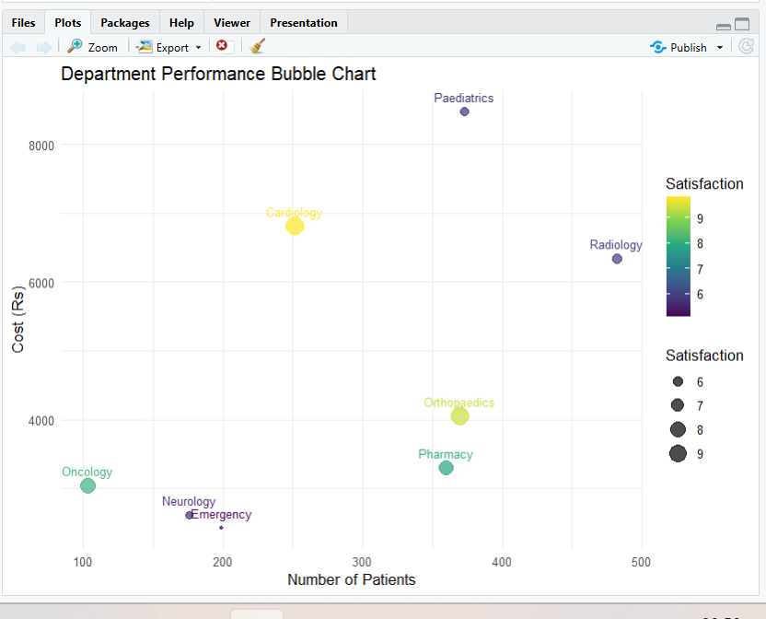
Result: The chart compares patient count, cost, and satisfaction across departments. Bubble size represents satisfaction.
Task 2: Identify the department with the highest patient count
R Code:
highest_patients <- df[which.max(df$patients), ]

print(highest_patients)
Output:

Result: The department with the highest patient count is identified from the dataset.
Task 3: Find the department with the highest satisfaction
R Code:
highest_satisfaction <- df[which.max(df$satisfaction), ]

print(highest_satisfaction)
Output:

Result: The department with the highest satisfaction score is identified.
Task 4: Calculate the correlation between patient count and cost
R Code:
correlation <- cor(df$patients, df$cost)

cat("Correlation between patients and cost:", correlation)
Output:
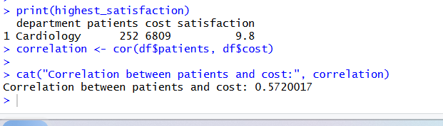
Result: A positive correlation indicates that patient count and cost tend to increase together. A negative correlation indicates that one tends to decrease as the other increases. A value near zero indicates a weak linear relationship.

Task 5: Give a recommendation
Recommendation: Use the bubble chart to compare patient count, cost, and satisfaction together. Departments with high patient counts and high costs should be reviewed for resource allocation, while satisfaction scores can help identify areas that may need improvement.

Q7. Hexbin Plots (5 Marks)
Task 1: Draw a hexbin plot and a plain scatterplot (1.5 Marks)
R Code:
set.seed(1281371)

n <- 3000
core <- runif(n) < 0.85

loan_lakh <- round(
ifelse(core, rnorm(n, 38.0, 5.4),
runif(n, 11.0, 65.0)), 1
)

income_k <- round(
ifelse(core,
52.0 - 0.59 * (loan_lakh - 38.0) / 5.4 +
sqrt(1 - 0.35) * 7.2 * rnorm(n),
runif(n, 16.0, 88.0)), 1
)

df <- data.frame(loan_lakh, income_k)

library(ggplot2)
library(viridis)

# Hexbin plot
ggplot(df, aes(x = loan_lakh, y = income_k)) +
geom_hex(bins = 25) +
scale_fill_viridis_c(name = "Count") +
labs(title = "Hexbin Plot of Loan Amount and Applicant Income",
x = "Loan Amount (Rs lakh)",
y = "Applicant Income (Rs thousand per month)") +
theme_minimal()

# Plain scatterplot
ggplot(df, aes(x = loan_lakh, y = income_k)) +
geom_point(alpha = 0.4) +
labs(title = "Scatterplot of Loan Amount and Applicant Income",
x = "Loan Amount (Rs lakh)",
y = "Applicant Income (Rs thousand per month)") +
theme_minimal()
Output:
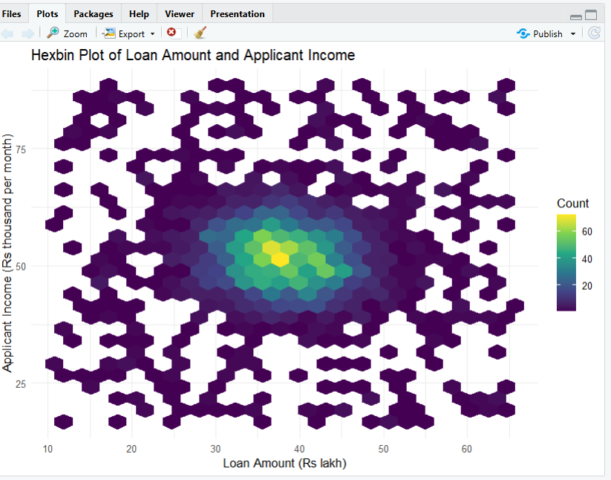
Result: The hexbin plot displays the number of records in each hexagonal region using colour intensity. The scatterplot displays individual records.
Task 2: Find the busiest cell in a 10 × 10 grid (1.5 Marks)
R Code:
x_group <- cut(df$loan_lakh, 10)
y_group <- cut(df$income_k, 10)

grid_table <- table(x_group, y_group)

busiest <- which(grid_table == max(grid_table), arr.ind = TRUE)[1, ]

x_range <- levels(x_group)[busiest[1]]
y_range <- levels(y_group)[busiest[2]]
cell_count <- grid_table[busiest[1], busiest[2]]
share <- cell_count / nrow(df) * 100

cat("Loan amount range:", x_range, "\n")
cat("Income range:", y_range, "\n")
cat("Count:", cell_count, "\n")
cat("Share of all points:", round(share, 2), "%\n")
Output:
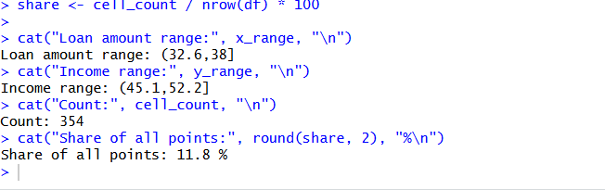
Result: The busiest cell is the grid cell containing the highest number of records. Its share represents the percentage of all 3,000 records that fall inside that cell.
Task 3: Count distinct pairs and explain the scatterplot limitation (1 Mark)
R Code:
distinct_pairs <- nrow(unique(df))

cat("Total records:", nrow(df), "\n")
cat("Distinct (x, y) pairs:", distinct_pairs, "\n")
cat("Repeated pairs:", nrow(df) - distinct_pairs, "\n")
Output:
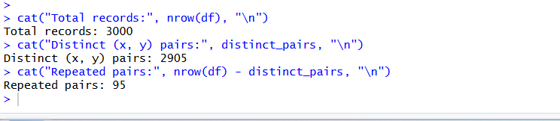
Result: The number of distinct pairs is calculated using nrow(unique(df)). A plain scatterplot can be misleading because multiple records may overlap at the same coordinates, hiding the true concentration of data points. The hexbin plot makes dense regions easier to identify.
Task 4: Recommendation for the Zonal Manager (1 Mark)
Recommendation: The Zonal Manager should use the hexbin plot to identify loan amount and applicant income ranges with the highest concentration of applicants. These ranges can help guide loan planning and resource allocation. Loan approval decisions should also consider credit history, repayment capacity, and other relevant risk factors.

Code of Conduct
I certify that this work is my own.
Signature: A. Yaswanth

